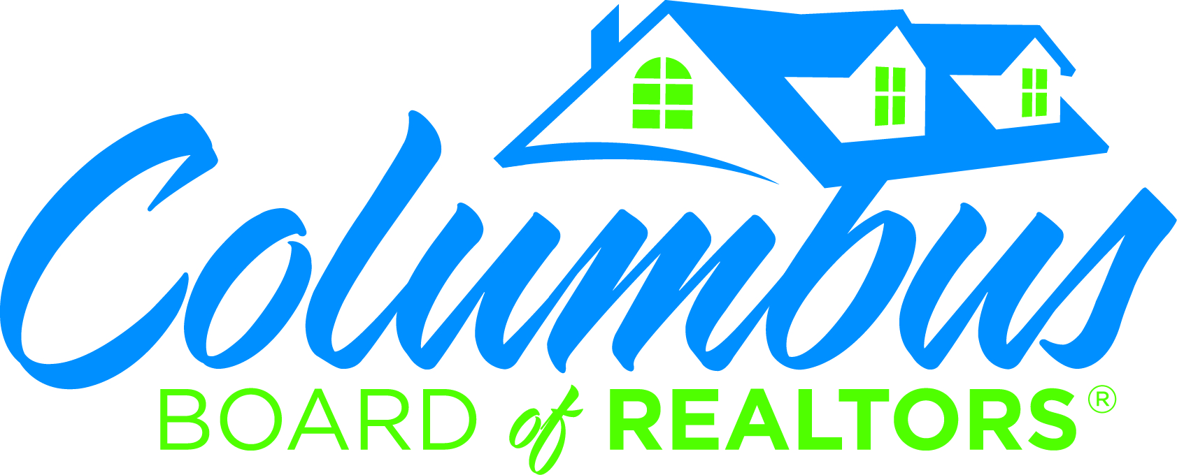

2016 COMMUNITY SERVICE AWARD NOMINATION

Deadline for submission to the CBOR office is Tuesday, January 31, 2017.
Presented at the annual Awards Luncheon on Friday, February 24, 2017.

Award Criteria

- To be awarded to an agent or broker who is in good standing with the Columbus Board of REALTORS® and who has exemplified unselfish service to charitable and community causes by giving of his/her time, talents, and gifts with the sole purpose of helping those in need or helping the community as a whole.
- Real estate production is not a consideration for this award.
- Nominations must be in writing and must be specific as to reasons why this member should be considered for this award.

Nominee’s Name: ___________________________________________________

Company: __________________________________________________________

Submitted by: _________________________________________________

Please use space below to describe why this member should be considered for this award (Humanitarian efforts, community and civic involvement, school activities, charity work, etc). Attach additional pages, if necessary.

____________________________________________________________________________

____________________________________________________________________________

____________________________________________________________________________

____________________________________________________________________________

Recent Community Service Award recipients:
Leah Braxton – 2015, 2014-Andrea Shields, 2013 – Charmaine Crabb
2012 – Pat Hunter ~ 2011 – Linda Boyd ~ 2010 – Smokey Bowers

